

|  |
| --- |
| Prototype1 |
| 21/08/17 11:56 |
| **Author:** John Doe  **File name:** Prototype1.vp  **Version** 1.0 |

|  |
| --- |
| Site Map |
|  |

|  |
| --- |
|  |

01. Site Map / Prototype1 

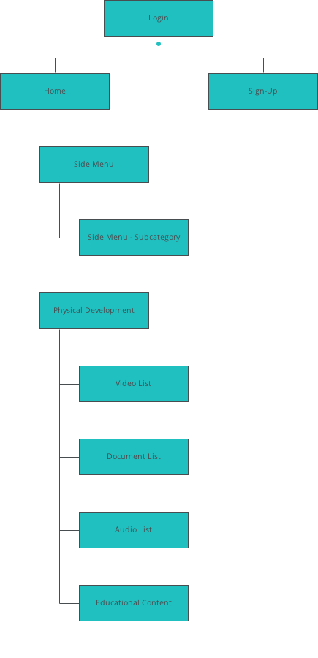

|  |
| --- |
| Screens |
|  |

|  |
| --- |
|  |

02. Screens / Prototype1 

Login

|  |
| --- |
|  |

Interactions

|  |  |
| --- | --- |
| 1 | **on Click:** goes to 'Home' with effect: slide left 🡪 |
| 2 | **on Click:** goes to 'Sign-Up' with effect: slide right 🡪 |

02. Screens / Prototype1 

Home

|  |
| --- |
|  |

Interactions

|  |  |
| --- | --- |
| 3 | **on Click:** goes to 'Side Menu' 🡪 |
| 4 | **on Click:** goes to 'Physical Development' with effect: slide left 🡪 |

02. Screens / Prototype1 

Sign-Up

|  |
| --- |
|  |

Interactions

|  |  |
| --- | --- |
| 5 | **on Click:** goes to 'Home' with effect: fade 🡪 |
| 6 | **on Click:** goes to 'Login' with effect: slide left 🡪 |

02. Screens / Prototype1 

Side Menu

|  |
| --- |
|  |

Interactions

|  |  |
| --- | --- |
| 7 | **on Click:** goes to 'Side Menu - Subcategory' 🡪 |
| 8 | **on Click:** goes to 'Side Menu - Subcategory' 🡪 |

02. Screens / Prototype1 

Side Menu - Subcategory

|  |
| --- |
|  |

Interactions

|  |  |
| --- | --- |
| 9 | **on Click:** goes to 'Side Menu' 🡪 |
| 10 | **on Click:** goes to 'Side Menu' 🡪 |

02. Screens / Prototype1 

Physical Development

|  |
| --- |
|  |

Interactions

|  |  |
| --- | --- |
| 12 | **on Click:** goes to 'Side Menu' 🡪 |
| 13 | **on Click:** goes to 'Video List' with effect: slide left 🡪 |
| 14 | **on Click:** goes to 'Document List' with effect: slide left 🡪 |
| 15 | **on Click:** goes to 'Audio List' with effect: slide left 🡪 |
| 16 | **on Click:** goes to 'Educational Content' with effect: slide left 🡪 |

02. Screens / Prototype1 

Video List

|  |
| --- |
|  |

Interactions

|  |  |
| --- | --- |
| 17 | **on Click:** goes to 'Side Menu' 🡪 |

02. Screens / Prototype1 

Document List

|  |
| --- |
|  |

Interactions

|  |  |
| --- | --- |
| 18 | **on Click:** goes to 'Side Menu' 🡪 |

02. Screens / Prototype1 

Audio List

|  |
| --- |
|  |

Interactions

|  |  |
| --- | --- |
| 19 | **on Click:** goes to 'Side Menu' 🡪 |

02. Screens / Prototype1 

Educational Content

|  |
| --- |
|  |

Interactions

|  |  |
| --- | --- |
| 20 | **on Click:** goes to 'Side Menu' 🡪 |

|  |
| --- |
| Templates |
|  |

|  |
| --- |
|  |

03. Templates / Prototype1 

Template 1

|  |
| --- |
|  |

|  |
| --- |
| Scenarios |
|  |

|  |
| --- |
|  |

04. Scenarios / Prototype1 

default

|  |
| --- |
|  |